**SIMAD UNIVERSITY**

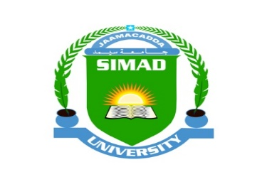

**Simad Community App**

**FACULTY OF COMPUTING   
SIMAD UNIVERSITY**

**Group F**

**November 2024**

**Problem Statement for Simad Community App**

**Students, alumni, and staff at Simad University** currently face significant challenges in staying connected, sharing information, and accessing resources efficiently. The lack of a centralized communication platform leads to:

1. **Fragmented Communication**: Information about university events, announcements, and opportunities is scattered across different channels (e.g., WhatsApp groups, email, social media). This makes it difficult for students and staff to stay updated and connected.
2. **Limited Networking Opportunities**: Alumni, current students, and staff struggle to connect meaningfully with each other due to the absence of a dedicated networking space. This results in missed opportunities for collaboration, mentorship, and knowledge sharing.
3. **Inefficient Access to University Resources**: Students often have difficulty accessing important resources such as academic schedules, exam results, course materials, and support services. The current systems are either outdated or not user-friendly.

These challenges lead to **disconnected communities**, missed opportunities for personal and professional growth, and a decline in overall student and staff engagement.

**Simad Community App** aims to address these issues by providing a unified, easy-to-use platform that facilitates communication, collaboration, and access to resources, fostering a stronger, more engaged university community.